Brandon Lee  
14010627X  
11/13/14  
Lab 8

*Complete project is included. Full working source code can be found there.*

**Problem 1 – Building Binary Trees (root is is shown as at the top)**

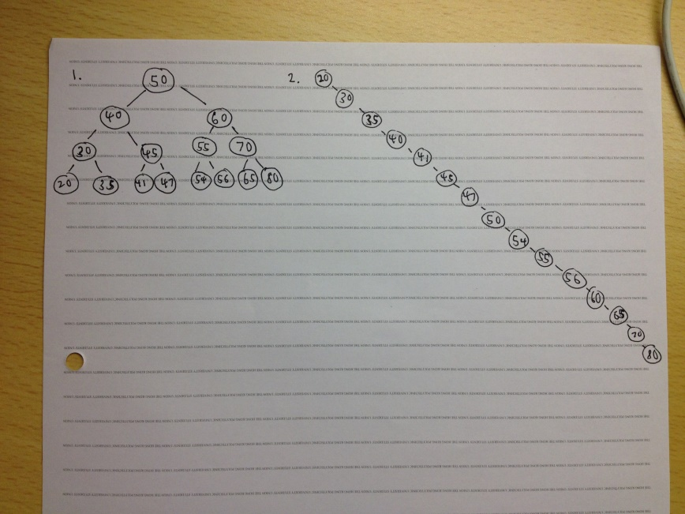 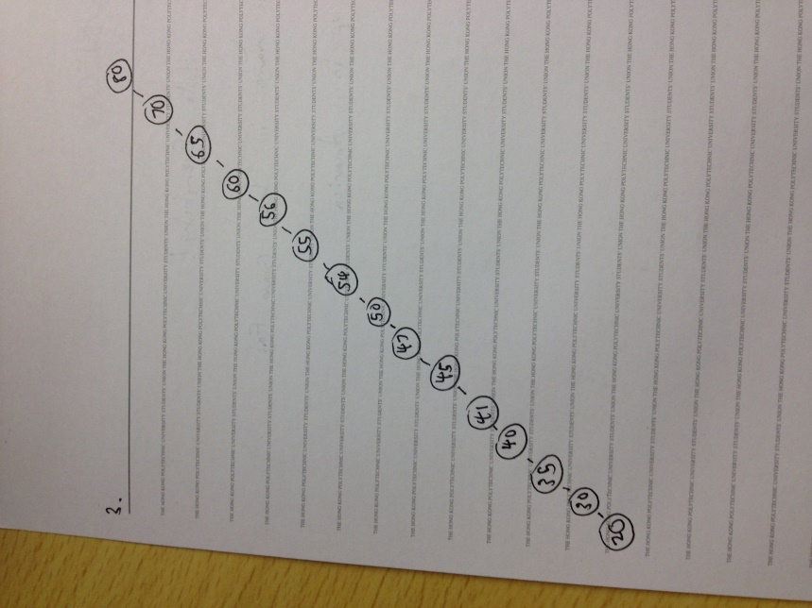

**Problem 2 – public double sum() method (press a to run):**

